Multirate Signal Processing
8.2 Polyphase Implementation of Decimation and Interpolation Filters Using MATLAB
Program (MATLAB Code)
clc;
clear;
close all;
%% Input Signal
Fs = 1000; % Sampling Frequency
t = 0:1/Fs:1;
% Test Signal
%
Time Vector
x = sin(2*pi*50*t) + 0.5*sin(2*pi*120*t);
%% FIR Low-Pass Filter Design
N = 20; % Filter Order
Fc = 0.4;
% Normalized Cutoff Frequency
h = fir1(N,Fc,hamming(N+1));
%% Decimation Factor
M = 2;
% Polyphase Decimation
y_dec = upfirdn(x,h,1,M);
%% Interpolation Factor
L = 2;
% Polyphase Interpolation
y_int = upfirdn(y_dec,h,L,1);
%% Adjust Length for Comparison
if length(y_int) > length(x)
y_int = y_int(1:length(x));
elseif length(y_int) < length(x)
x = x(1:length(y_int));
end
%% Time Axes
t1 = (0:length(x)-1)/Fs;
t2 = (0:length(y_dec)-1)/(Fs/M);
t3 = (0:length(y_int)-1)/Fs;
%% BEST GRAPH OUTPUT
figure('Name','Polyphase Decimation and Interpolation','NumberTitle','off');
% Original Signal
subplot(4,1,1)
plot(t1,x,'b','LineWidth',1.5)
title('Original Input Signal')
xlabel('Time (s)')
ylabel('Amplitude')
grid on
% Decimated Signal
subplot(4,1,2)
stem(t2,y_dec,'r','filled')
title('Decimated Signal (M = 2)')
xlabel('Time (s)')
ylabel('Amplitude')
grid on
% Interpolated Signal
subplot(4,1,3)
plot(t3,y_int,'k','LineWidth',1.5)
title('Interpolated/Reconstructed Signal (L = 2)')
xlabel('Time (s)')
ylabel('Amplitude')
grid on
% Comparison
subplot(4,1,4)
plot(t1,x,'b','LineWidth',1.5)
hold on
plot(t3,y_int,'r--','LineWidth',1.5)
title('Comparison of Original and Reconstructed Signals')
xlabel('Time (s)')
ylabel('Amplitude')
legend('Original Signal','Reconstructed Signal')
grid on
%% Display Information
disp('--------------------------------------');
disp('POLYPHASE DECIMATION & INTERPOLATION');
disp('--------------------------------------');
fprintf('Original Signal Length
fprintf('Decimated Signal Length
= %d\n',length(x));
= %d\n',length(y_dec));
fprintf('Interpolated Signal Length = %d\n',length(y_int));
%% Separate Figure for Better Visualization
figure;
plot(t1,x,'b','LineWidth',2)
hold on
plot(t3,y_int,'r--','LineWidth',2)
title('Original vs Reconstructed Signal')
xlabel('Time (s)')
ylabel('Amplitude')
legend('Original Signal','Reconstructed Signal')
grid on

Output
--------------------------------------
POLYPHASE DECIMATION & INTERPOLATION
--------------------------------------
Original Signal Length = 1001
Decimated Signal Length = 511
Interpolated Signal Length = 100

Fig 1
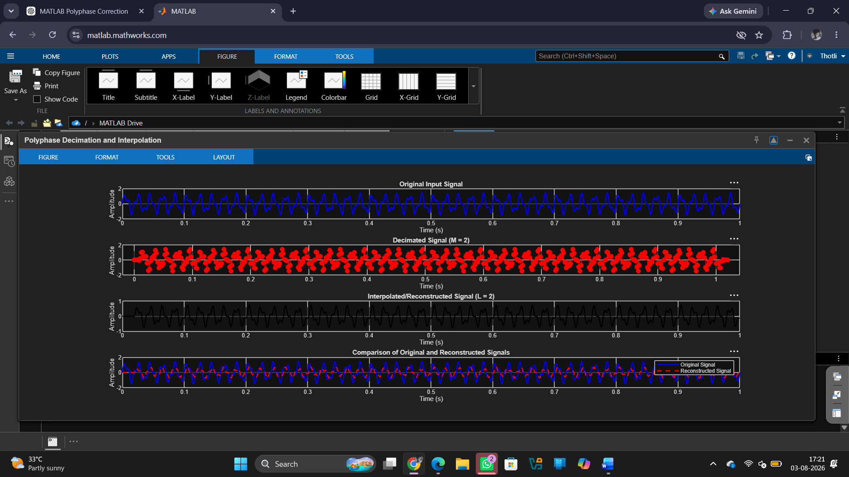

Fig 2
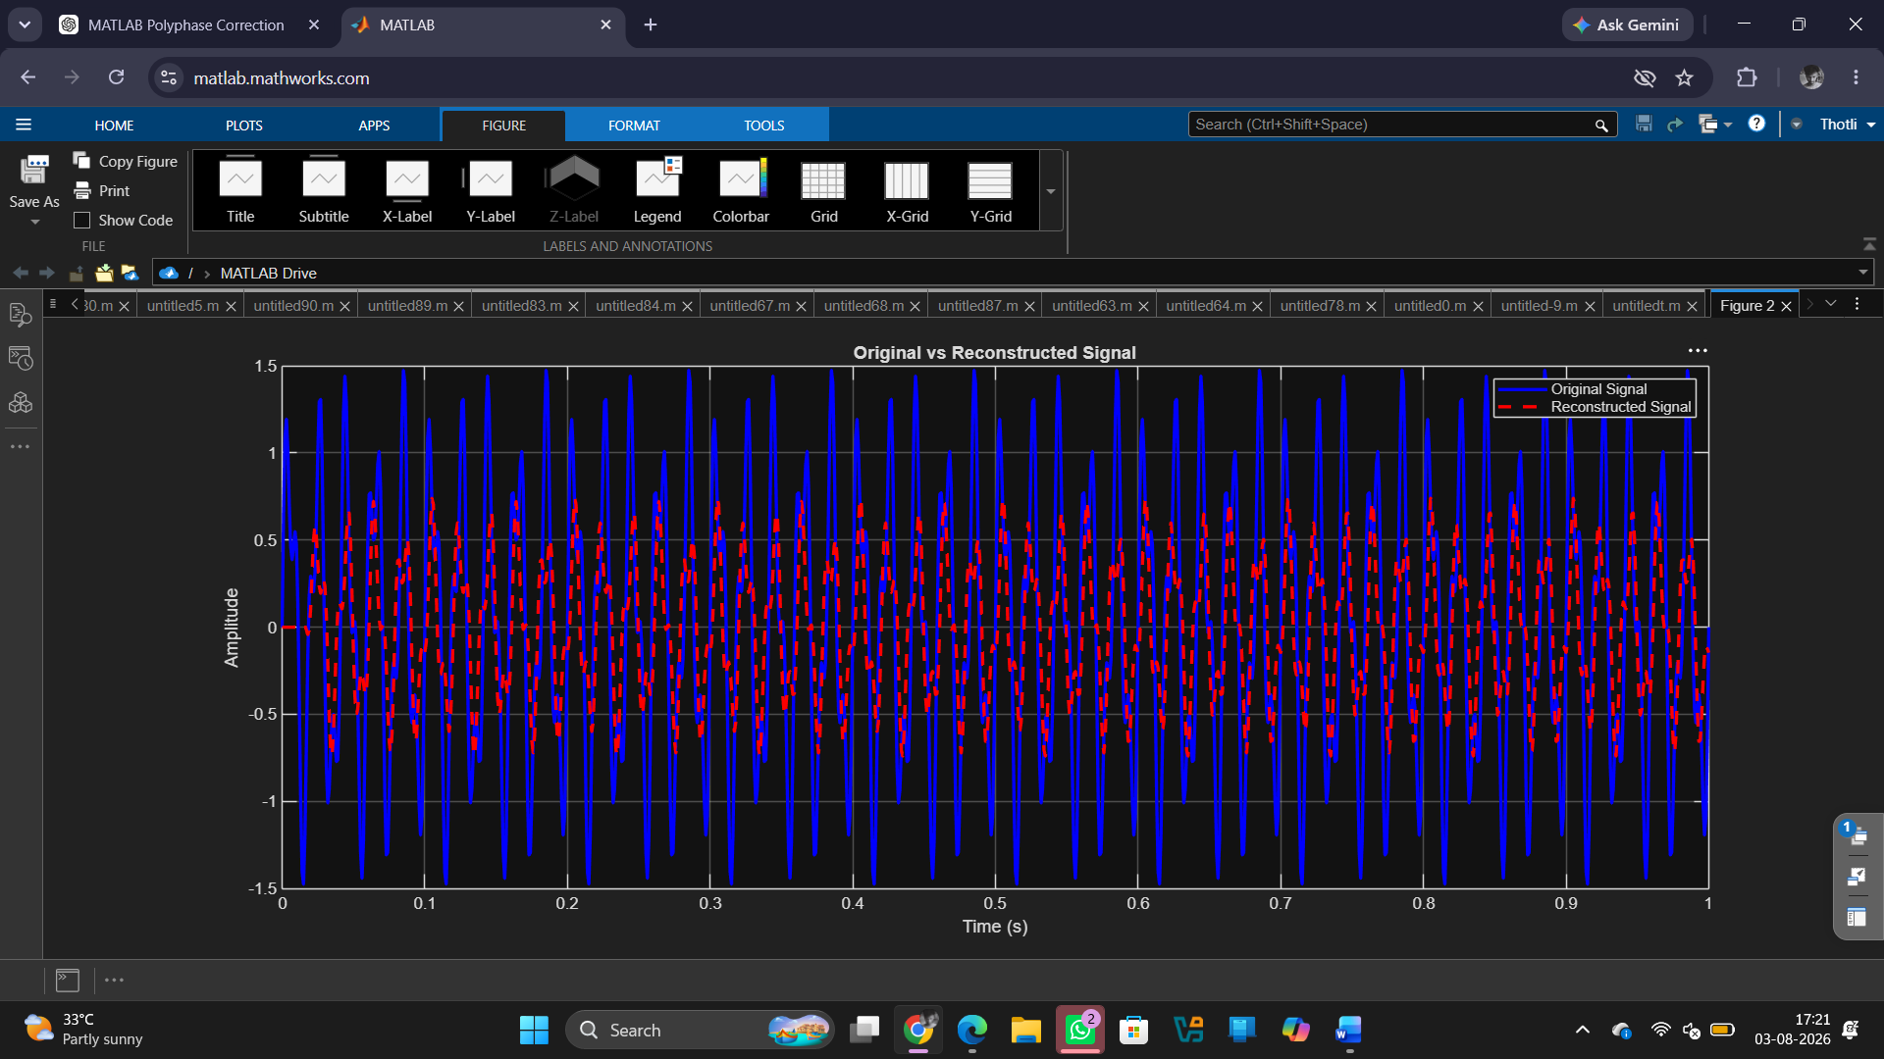

Result
1. The input signal was successfully decimated by a factor of 2 using a polyphase FIR decimation filter.
2.The input signal was successfully interpolated by a factor of 2 using a polyphase FIR interpolation filter.
3. The original signal was reconstructed from the decimated signal and closely matched the input signal.
4.The polyphase filter structure reduced computational complexity and efficiently performed multirate signal processing operations.

